OLIVER’S BATTERY LONG TERM CURRICULUM PLANNING – Year 2

Year Group: 3 | Autumn 1 | Autumn 2 | Spring 1 | Spring 2 | Summer 1 | Summer 2
Project title | Fables | The Great Fire of London | Journeys | The Extraordinary Gardner | Florence Nightingale | Art Attack
Key question | What’s the message? | Why did it last so long? | Where could we go? | How does your garden grow? | What did she do? | Can you spot the tiger?
Driver | Science: animals and habitats/art | History Link with materials (science) | Geography | Science: Plants  Geography/Locality comparison | History | Art
Hook | A letter from the Lion | Visit from fire fighters | Email from the Queen to say she has lost her handbag. | Trip to HIlliers Arboretum. | Role play of injured soldier | Visit from local artist.
Outcome | Story time with year 1 to share the stories written. | Fire of London Exhibition | Share creative writing piece with year 1.  Role play | Posters up in the poly-tunnel to inform children about how to grow. | Dress up day | Art Exhibition
Key texts | Text: Hare and Tortoise by Alison Murray Text: The Lion Inside by Rachel Bright & Jim Field Text: The Lion and the Mouse by Jerry Pinkney  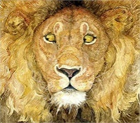  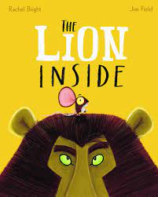 | Vlad and the Great Fire of London  By Kate Cunningham  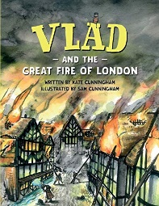 | The Queen’s Handbag  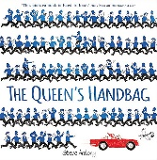  by By Steve Antony  Journey  By Aaron Becker  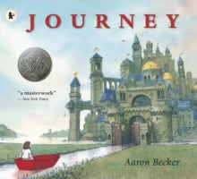  Local environment study branching out into the Uk and  features. | The Extraordinary Gardner by Sam Boughton  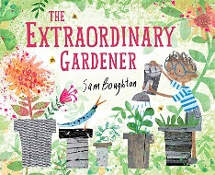 | Florence Nightingale…Little People Big Dreams  By Maria Isabel Sanchez Vegara  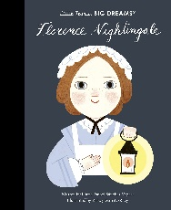 | The Fantastic jungles of Henri Rousseau  by Michelle Markel  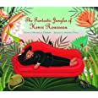
English genre and form | *Re-count of the race  *Poster writing  *Character description  * Story writing  Write text to go with textless book. | *Information text  *Setting description writing  *Diary entries  *Fire safety Poster | *Persuasive writing:  Non-fiction guide book for tourists.  *Description writing  *Setting description  *Thought bubble/speech bubble writing  *Innovate story | *Non-fiction report  *Instruction writing  *Character and setting description writing | *Diary writing  *Letter writing  * Setting description  *Thought bubble/speech bubble writing | *Biography writing  *News paper article.  *Letter writing  *Character description writing  *Setting description
NC objectives | Science  Planning: Unit Animal Life Cycles  NC:  Living Things and their habitats..  *Identify that most living things live in habitats to which they are suited and describe how different habitats provide for the basic needs of different kinds of animals and plants, and how they depend on each other.  *Identify and name a variety of common animals that are birds, fish, amphibians, reptiles, mammals and invertebrates.  Identify and name a variety of common  animals that are carnivores, herbivores and omnivores.  Art and Design  Sculpture  Use a combination of shapes.  Include lines and texture.  Use rolled up paper, straw, paper card and clay as materials.  Use techniques such as rolling, cutting, moulding and carving.  Make a clay animal. Use clay tools and fingers to create texture and lines.  Art and Design  Drawing  Use repeating and overlapping shapes.  Press,roll, rub and stamp to make prints.  Christmas card competition. | History  To investigate and interpret the past.  Observe or handle evidence to ask questions and find answers to questions about the past.  Ask questions such as: What was it like for people? What happened? How long ago?  Use artefacts, pictures, stories, online sources and databases to find out about the past.  Identify some of the different ways the past has been represented.  To build an overview of world history.  Describe historical events.  Describe significant people from the past.  Recognise that there are reasons why people in the past acted as they did.  Geography  Identify the key features of a location in order to say whether it is a city, town, village, coastal or rural area.  Science  Planning: Unit  Changing Materials:  Materials Buildings  Rocks, wood, ceramics, metals  Investigation into materials and their properties.  Investigate.  Distinguish between an object and the material from which it is made.  Identify and name a variety of everyday materials, including wood, plastic, glass, metal, water and rock.  Describe the simple physical properties of a variety of everyday materials.  Compare and group together a variety of everyday materials on the basis of their physical properties.  Find out how the shapes of solid objects made from some materials can be changed by squashing, bending, twisting and stretching.  Identify and compare the suitability of a variety of everyday materials, including wood, metal, plastic, glass, brick/rock, and paper/cardboard for particular uses.  Art and Design  Collage  Use a combination of materials that are cut, torn and glued.  Sort and arrange materials.  Mix materials to create texture.  Silhouette pictures  DT  Textiles  Shape textiles using templates.  Join textiles using running stitch.  Colour and decorate textiles using a number of techniques (such as dying, adding sequins or printing)  Christmas decorations. | Geography  Use world maps, atlases and globes to identify the United Kingdom and its countries, as well as the countries, continents and oceans studied.  Name, locate, and identify characteristics of the four countries and capital cities of the United Kingdom and its surrounding seas.  Name and locate the world’s continents and oceans.  Science  Planning: Unit  Pushes and pulls  Pushes Pull and their effects.  How things move.  Forces change how things move.  Making forces bigger.  Forces change shapes.  Art and Design  Show pattern and texture by using dots and lines.  Show different tones by using coloured pencils. | Science  Planning: Unit  New Plants  Plants  Identify and name a variety of common plants, including garden plants, wild plants and trees and those classified as deciduous and evergreen.  Identify and describe the basic structure of a variety of common flowering plants, including roots, stem/trunk, leaves and flowers.  Observe and describe how seeds and bulbs grow into mature plants.  Find out and describe how plants need water, light and a suitable temperature to grow and stay healthy.  DT  Food  Cut, peel or grate ingredients safely and hygienically.  Measure or weigh using measuring cups or electronic scales.  Assemble or cook ingredients.  Make salad/soup  Geography  Understand geographical similarities and differences through studying the human and  physical geography of a small area of the  United Kingdom and a contrasting non-European country.  Look at plants etc in our gardens and compare with St Lucia.  Art and Design  Textiles  Shape textiles using templates.  Colour and decorate textiles using a number of techniques (such as dying, adding sequins or printing)  Easter decorations. | History  Find out about the lives of significant individuals in the past who have contributed to national and international achievements. Some should be used to compare aspects of life in different periods.  To investigate and interpret the past.  Observe or handle evidence to ask questions and find answers to questions about the past.  Ask questions such as: What was it like for people? What happened? How long ago?  Use artefacts, pictures, stories, online sources and databases to find out about the past.  Discrete Unit  Science  Planning: Unit  Changing Materials  Clothing | Art  Describe the work of notable artists, artisans and designers.  *Use some of the ideas of artists studied to create pieces.  *Use weaving to create a pattern  *Paint: colour mixing.  Use different size brushes to create different effects.  Join material using glue and/or a stitch.  Create a puppet for diorama.  DT  Cut materials safely using tools provided.  Measure and mark out to the nearest centimetre.  Demonstrate a range of cutting and shaping techniques (such as tearing, cutting, folding and curling.)  Create products using levers, wheels and winding mechanisms.  Design products that have a clear purpose and intended user.  Make products, refining the design as work progresses.  Use software to design.  Create products using levers, wheels and winding mechanisms.  Create a diorama of jungle scene with tiger and animal puppets and curtain winding mechanism.  History  Find out about the lives of significant individuals in the past who have contributed to national and international achievements.
RE | Theme/Unit: Harvest  Key concept: Celebration | Theme/Unit: Nativity journeys  Key concept: Journey’s end | Theme/Unit: Creation stories  Key concept: Creation | Theme/Unit: Easter  Key concept: Sad and happy | Theme/Unit: Passover  Key concept: Remembering | Theme/Unit: Special places (church)  Key concept: Specialness
PSRE | Year 2  Feelings and Emotions | Year 2  Rights and Responsibilities | Year 2  Keeping Safe | Year 2  Diversity | Year 2  Growing and Changing  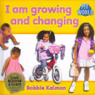 | Year 2  Healthy Relationships  http://elstonhall.org.uk/documents/home_learning/PSHE/KS1.pdf
Music | Listen To Me  Music  To Compose  Choose sounds to create an effect.  Sequence sounds to create an overall effect.  Use percussion instruments and natural objects,  eg. leaves to create a soundscape of autumn animals in the forest.  To Perform  Take part in singing, accurately following the melody.  Follow instructions on how and when to sing or play an instrument.  Make and control long and short sounds, using voice and instruments.  Imitate changes in pitch.  Learn and perform Autumn and Harvest songs using voices and percussion instruments. | Listen To Me  Music  To Perform  Take part in singing, accurately following the melody.  Song: London’s Burning: Sing in a round  To compose  Create a mixture of different sounds (long and short, loud and quiet, high and low).  Sequence sounds to create an overall effect.  Create a soundscape of Fire of London. | Listen To Me  Music  To Transcribe  Use symbols to represent a composition and use them to help with a performance.  In groups create a soundscape of a journey.  Can you guess where the journey is to? | Listen To Me  Music  Charanga  - Take part in singing, accurately following the melody.  - Follow instructions on how and when to sing or play an instrument. | Listen To Me  Music  Charanga  - Take part in singing, accurately following the melody.  - Follow instructions on how and when to sing or play an instrument. | Listen To Me  Music  Charanga  - Take part in singing, accurately following the melody.  - Follow instructions on how and when to sing or play an instrument.

